2020 02 27 NR Daily Log

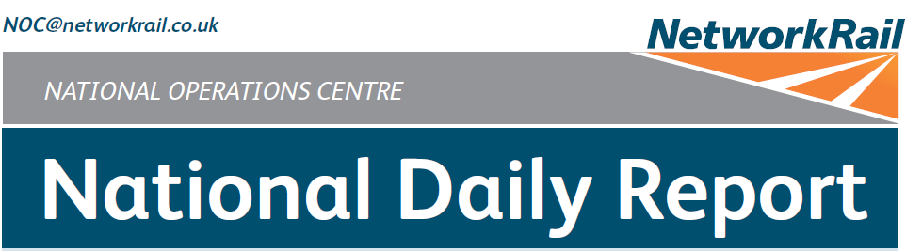



***DATE OF REPORT: NOC MANAGER 0700 – 1900:***

***NOC MANAGER 1900 – 0700:***

***DUTY CONTROLLER 0630 – 1830:***

***DUTY CONTROLLER 1830 – 0630:***

***SUPPORT CONTROLLER 0630 – 1830:***

***SUPPORT CONTROLLER 1830 – 0630:***

***LONDON CONTROLLER 0700 – 1900:***

***LONDON CONTROLLER 1900 – 0700:***

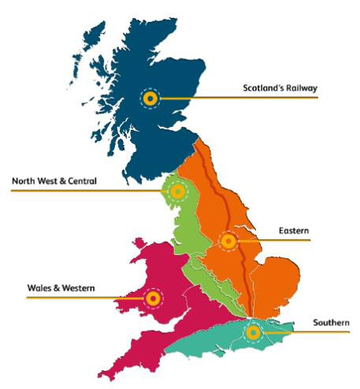

Thursday 27th February 2020 Mark Elkin

Matthew Whitfield Ivan Stewart David Wiltshire Graham McIntosh Karl Biswell Martin Dineen Dominic Duggan

# TABLE OF CONTENTS

1. WRONG SIDE FAILURE REPORTS 3
2. SIGNALS PASSED AT RED (CATEGORY ‘A’) 3
3. DERAILMENTS 4
4. COLLISIONS 4
5. TRAIN OR VEHICLE RUNAWAY 4
6. OPERATIONAL INCIDENTS 5
7. TRAINS WITH STRANDED PASSENGERS 6
8. SIGNIFICANT POSSESSION PROBLEMS 6
9. FATALITIES 6
10. INJURIES/ASSAULTS 6
11. NEAR MISSES 6
12. RAILWAY CRIME 6
13. STATION OVERRUNS 6
14. BROKEN RAILS/TRACK DEFECTS 7
15. POWER FAILURES 7
16. POINTS FAILURES 7
17. SIGNALS/SIGNALLING SYSTEMS FAILURES 7
18. TRACK CIRCUIT & AXLE COUNTER FAILURES 8
19. BRIDGE STRIKES 8
20. ROAD VEHICLE INCURSIONS (NON-LEVEL CROSSINGS) 9
21. TRACTION FAILURES 9
22. WEATHER-RELATED PROBLEMS 10
23. FIRES 10
24. WILD REPORTS & HABD ACTIVATIONS 10
25. GROUP STANDARDS GE/RT8250 & GO/RT3350 12
26. TPWS 12
27. MISCELLANEOUS 12
28. REVIEW TABLE 13
29. REAL TIME PERFORMANCE FIGURES 14

## North West and Central (WCMLS) – CCIL 2100740 / Fault No. 883474

***01 WRONG SIDE FAILURE REPORTS***

At 1405 (Tue) it was advised that Kempston Hardwick AHB had failed and the barriers had lowered with no trains in the area but as a lorry was traversing the crossing, bringing the barriers down on top of the vehicle. A Mobile Operations Manager was sent to site to release the lorry. The issue was believed to have arisen as the HXB3 interlocking system had correctly lowered the barriers as 2S18, West Midlands Trains, 1355 Bedford – Bletchley approached, had raised the barriers once the train arrived at Kempston Hardwick station but had then detected the presence of the train in close proximity to the crossing and had lowered the barriers onto the road vehicle. At 1845 (Tue) Kempston Hardwick and Stewartby AHB Level Crossings were taken under local control due to the interlocking issues. This continued throughout Wednesday 26/02. At 1119 (Thu), after track circuit ‘KP’ on the Down line at Kempston Hardwick failed to show occupied during the passage of 4H03, GB Railfreight, 1003 Bletchley – Peak Forest, a Senior Signalling Technician advised the track circuits could not be relied upon to operate the Level Crossings and as a result no traffic should traverse them without an attendant present. At 1306 (Thu) a block to all traffic between Bedford and Bletchley was imposed due to the safety concerns with the signalling system. S&T staff attended to begin non-destructive testing.

|  |  |  |  |  |  |  |  |
| --- | --- | --- | --- | --- | --- | --- | --- |
| TRUST 810886 IQNA (since 25/02/20) | | | | | | | |
| Cancelled | 2 | Part Cancelled | 20 | Trains Delayed | 34 | Minutes | 292 |

***02 SIGNALS PASSED AT RED (CATEGORY ‘A’)***

## North West and Central (WCMLS) – CCIL 2101698 / Fault No. 883628

At 0835, 2S07, West Midlands Trains, 0801 Bletchley - Bedford, passed MV23 signal on the Down Main line between Lidlington and Millbrook at red by ½ a coach length. When questioned, the driver stated that they were distracted by a 20mph ESR (group 2 cause). After consultation with West Midlands Trains, the driver was judged unfit to continue and was met on arrival at Millbrook by the driver manager and ‘for cause’ screening was arranged.

|  |  |  |  |  |  |  |  |
| --- | --- | --- | --- | --- | --- | --- | --- |
| TRUST 816514 TEJ4 | | | | | | | |
| Cancelled | 3 | Part Cancelled | 1 | Trains Delayed | 4 | Minutes | 90 |

## Southern (Wessex) – CCIL 2101713 / Fault No. 465058

At 0928, 2R30, South Western Railway, 0914 Romsey - Romsey, passed E744 signal on the Up Slow line at Millbrook at red by three coach lengths. The train was brought to a stand by a TPWS activation. The driver was challenged and stated they had read across E746 signal on the adjacent Up Fast line showing a proceed aspect (group 3 cause). The driver was judged fit to continue and was met on arrival at Southampton Central.

|  |  |  |  |  |  |  |  |
| --- | --- | --- | --- | --- | --- | --- | --- |
| TRUST 816801 THYM | | | | | | | |
| Cancelled | 0 | Part Cancelled | 0 | Trains Delayed | 3 | Minutes | 8 |

## North West and Central (WCMLS) – CCIL 2101720 / Fault No. 883642

At 0948 5R16, Avanti West Coast, 0912 London Euston – Wembley TC, passed CS1 signal on the Up Carriage line at Willesden Carriage Sidings at red by one signal section. When questioned, the driver stated they did not correctly observe the signal aspect (group 2 cause). After consultation with Avanti West Coast, the driver was judged unfit to continue and was met and relieved on site.

|  |  |  |  |  |  |  |  |
| --- | --- | --- | --- | --- | --- | --- | --- |
| TRUST 816718 THF1 | | | | | | | |
| Cancelled | 0 | Part Cancelled | 0 | Trains Delayed | 2 | Minutes | 7 |

## North West and Central (WCMLS) – CCIL 2101810 / Fault No. 883686

At 1411, 1Y24, West Midlands Trains, 1220 Rugeley Trent Valley – London Euston, passed RY266 signal on the Up Northampton line at Crick at red by ½ a coach length. When questioned, the driver stated they misread the signal aspect (group 2 cause). After consultation with West Midlands Trains, the driver was judged unfit to continue, another driver who was travelling as a passenger took the train forward to Northampton, where the service terminated.

|  |  |  |  |  |  |  |  |
| --- | --- | --- | --- | --- | --- | --- | --- |
| TRUST 817228 TEJB | | | | | | | |
| Cancelled | 0 | Part Cancelled | 6 | Trains Delayed | 47 | Minutes | 318 |

## Wales & Western (Wales) – CCIL 2101873 / Fault No. 461723

At 1505, 2C33, Transport for Wales, 1433 Radyr - Coryton, passed CF2896 signal on the Up Llandaff line between Cardiff Central and Cardiff Queen Street at red by one metre. The driver was challenged and stated their view of CF2896 signal had been affected by low sun (group 4 cause). The driver was judged fit to continue and was met on arrival at Cardiff Queen Street.

|  |  |  |  |  |  |  |  |
| --- | --- | --- | --- | --- | --- | --- | --- |
| TRUST 817341 THLA | | | | | | | |
| Cancelled | 2 | Part Cancelled | 2 | Trains Delayed | 37 | Minutes | 185 |

## North West and Central (WCMLS) – CCIL 2102091

At 2334 6J01, Colas, 2057 Washwood heath – Henley-In-Arden, passed TB3482 signal on the Up North Warwick line at Henley-In-Arden at red without authority, travelling beyond detonator protection into a possession. The train was stood at the signal awaiting acceptance into engineering possession WON 48, Item 138, Whitlocks End – Henley-in-Arden, All lines blocked, 2320 (Thu) – 0630 (Fri), a West Mids & Chilterns (IQR3) Route Businesses EW managed possession. The driver had spoken with the signaller to inform them they had arrived at the signal and the signaller instructed the driver not to proceed until receiving authority from the signaller. The PICOP then lifted the detonator protection and told the driver to proceed, resulting in the driver passing the signal at red without authority from the signaller (group 2 cause). The driver stated they thought they were told to proceed on authority from the signaller or the PICOP. ‘For cause’ screening was arranged for the staff involved and a relief driver sourced. Work in the possession continued and a Mobile Operations Manager was sent to site to conduct an investigation, ongoing at the close of this Report.

***03 DERAILMENTS***

None.

***04 COLLISIONS***

None.

***05 TRAIN OR VEHICLE RUNAWAY***

None.

## Eastern (East Coast) – CCIL 2101528

At 0021 (Thu) it was reported that an isolation had been taken for LNEN WON 48, Item 110, Sunderland South Junction – Boldon West Junction/South Hylton, All lines blocked, 0020 (Thu) – 0510 (Thu), an LNE Network Operations North managed possession, whilst 2I04, Nexus (Tyne & Wear Metro), 2347 South Hylton – Regent Centre, was still in the section. It was advised that this occurred due to the isolation overlay not incorporating the full extent of the isolations to be taken, and this had not been checked against the isolation diagrams. The isolation was returned, allowing 2I04 to take power and resume service. The signaller reported that they thought 2I04 had passed through the section being isolated. 2I04 had been delayed through the section at Pelaw Metro Junction due to reports of a trespass which led to the service being stopped and cautioned. The signaller was relieved of duty and ‘for cause screened’.

|  |  |  |  |  |  |  |  |
| --- | --- | --- | --- | --- | --- | --- | --- |
| TRUST 812407 TPGA | | | | | | | |
| Cancelled | 0 | Part Cancelled | 0 | Trains Delayed | 8 | Minutes | 45 |

## Southern (Sussex) – CCIL 2101552

At 0208 it was determined that a member of staff contracted to RTI Solutions, carrying out work for Atkins Rail, had placed protection for a Line Blockage in an unsafe position at Southerham Junction. GZAC Ref. 6694593 outlined the need to place protection clear of No.82 points, however the individual placed protection at TW15 signal on the Down Eastbourne line. TW15 was specified as a protecting signal only. Work was stood down immediately once the error had been realised.

## Scotland – CCIL 2101776

At 1119, the conductor onboard 1R47, ScotRail, 1115 Edinburgh Waverley – Glasgow Queen Street reported that the train was not fully accommodated within the platform at Haymarket station when the driver released the doors. They advised that they took control of the doors and advised the driver, who drew the train forward before station duties were carried out. A ScotRail manager met the service at Glasgow Queen Street and reports were received from the trainee driver, driver instructor and conductor.

## Wales and Western (Western) – CCIL 2101777

At 1127 a TOPS-generated warning was received stating that locomotive 89212, working 5Z12, GB Railfreight, 1056 West Ruislip – Eastleigh Works, was deregistered. The Rolling Stock Library (RSL) were contacted and reported that the required documentation had not yet been received. Western Route Control were advised and 5Z12 was held at Hanwell pending investigation. At 1205 it was confirmed by the RSL that the required documentation had been received. The registration process was completed at 1216 and TOPS updated at 1233.

## Eastern (East Coast) – CCIL 2101783

At 1200, upon arrival at Essex Road the driver of 2B62, Govia Thameslink Railway, 1155 Moorgate – Hertford North released the doors on the non-platform side of the train. The doors were unable to open due to a safety system on the unit and no passenger incidents occurred. The service was terminated at Finsbury Park and ran as ECS to Hornsey.

|  |  |  |  |  |  |  |  |
| --- | --- | --- | --- | --- | --- | --- | --- |
| TRUST 816978 TETG | | | | | | | |
| Cancelled | 1 | Part Cancelled | 9 | Trains Delayed | 13 | Minutes | 123 |

## Eastern (East Coast) – CCIL 2101823

At 1308, the signaller at Driffield inadvertently replaced D5 signal on the Down Bridlington line at Duffield to red in front of 1W43, Northern, 1057 Sheffield – Scarborough. The driver was unable to stop and passed the signal at red. The driver was fit to continue when the circumstances were explained.

|  |  |  |  |  |  |  |  |
| --- | --- | --- | --- | --- | --- | --- | --- |
| TRUST 817129 CQG8 | | | | | | | |
| Cancelled | 0 | Part Cancelled | 0 | Trains Delayed | 1 | Minutes | 4 |

|  |  |  |  |  |  |
| --- | --- | --- | --- | --- | --- |
| ***Region / Route*** | ***Train*** | ***Since*** | ***Between*** | ***OUTCOME*** | ***CCIL*** |
| Eastern (N&E) | 2H36, Northern, 1156 Leeds - Skipton | 1203 -  1236 | Kirkstall Forge – Apperley Junction | Driver isolated bogie and proceeded. | 2101796 |
| Scotland | 2J79, ScotRail, 1134 Edinburgh Waverley – Glasgow Queen Street | 1223 -  1308 | Greenhill Lower Junction – Cumbernauld | Points failure was rectified allowing service to proceed. | 2101803 |
| Scotland | 1L05, ScotRail, 1437 Edinburgh Waverley - Perth | 1454 -  1533 | Queensferry North – Inverkeithing | Following examination of the bridge, normal signalling resumed. | 2101872 |
| NW&C (C) | 2D54, Chiltern, 1824 London Marylebone – Stratford Upon Avon | 1956 -  2111 | Kings Sutton - Heyford | Went forward after Mobile Operations Manager secured failed points | 2102001 |

***08 SIGNIFICANT POSSESSION PROBLEMS***

None.

***09 FATALITIES***

None.

***10 INJURIES/ASSAULTS***

None.

***11 NEAR MISSES***

## Eastern (North & East) – CCIL 2101573

At 0435 the driver of 1P05, (TransPennine Express), 0301 Manchester Piccadilly - York, reported a near miss on the Up line between East Garforth and Peckfield crossover with a person who was standing in the four foot as the train approached. The driver was shaken by the incident but was fit to continue to York. The BT Police (ref. 46) were advised. A Mobile Operations Manager attended with no persons being found. At 0618 the person was seen again at bridge HUL4/14. Services were cautioned, the Mobile Operations Manager and BT Police reported at 0650 that the BT Police had the person in custody and were clear of the track, allowing both lines to reopen without restriction.

|  |  |  |  |  |  |  |  |
| --- | --- | --- | --- | --- | --- | --- | --- |
| TRUST 815903 XQGL | | | | | | | |
| Cancelled | 3 | Part Cancelled | 11 | Trains Delayed | 161 | Minutes | 1328 |

***12 RAILWAY CRIME***

None.

***13 STATION OVERRUNS***

None.

## Southern (Kent) – CCIL 2101556 / Fault No. 464819

At 0249 No.7152 points on the Down Charing Cross line at Borough Market Junction were found to have a 200mm defect, together with the switch rail found to be rising over the stock rail. The overnight discovery resulted in a ban to facing movements in the Normal position, preventing movements into London Bridge platform 7. The signaller at Three Bridges was tasked with running Down Charing Cross line traffic into platform 6 only. The setback resulted in an array of Southeastern cancellations, amendments and diversions via London Victoria – ticket acceptance was agreed with DLR and LUL from 0445. Repairs were carried out within an additional 0030 – 0450 (Fri) possession.

|  |  |  |  |  |  |  |  |
| --- | --- | --- | --- | --- | --- | --- | --- |
| TRUST 815855 IQM1 | | | | | | | |
| Cancelled | 57 | Part Cancelled | 76 | Trains Delayed | 223 | Minutes | 1071 |

***15 POWER FAILURES***

None.

***16 POINTS FAILURES***

## North West and Central (C) – CCIL 2102001 / Fault No. 883714

At 1956 the Cherwell Valley signaller advised there was no Reverse detection on OL113 points on the Down line at Aynho Junction. As a result, services could not be routed from Bicester towards Aynho Junction. One service was trapped (see section **07** of this Report). A Mobile Operations Manager was sent to site and a block to traffic imposed at 2003 with the Oxford signaller and Swindon TRC. 1R58, Chiltern, 1915 London Marylebone – Birmingham Moor Street was stood at Bicester North on the Down Main line. A shunt move at the north end of the station was performed to allow the service to proceed running Bi- Directionally. By 2111 the Mobile Operations Manager had arrived on site and secured the points into the Reverse position, allowing the trapped service to proceed and normal signalling to resume. S&T staff attended overnight to investigate the cause of the failure and carry out remedial work.

|  |  |  |  |  |  |  |  |
| --- | --- | --- | --- | --- | --- | --- | --- |
| TRUST 818040 IQEB | | | | | | | |
| Cancelled | 1 | Part Cancelled | 4 | Trains Delayed | 69 | Minutes | 1041 |

***17 SIGNALS/SIGNALLING SYSTEMS FAILURES***

## Eastern (East Coast) – CCIL 2101741 / Fault No. 789336

At 1020, the driver of 5E62, Greater Anglia, 0844 London Liverpool Street – Bounds Green, reported that K832 ground position light signal on the Run Round Loop line at Bowes Park had reverted from Off to On as the train approached. The driver was unable to stop and passed the signal at red. S&T staff working on a track circuit at Bounds Green advised that they had inadvertently occupied the track circuit resulting in the change of aspect. The driver was fit to continue.

## Eastern (East Coast) – CCIL 2101802 / Fault No. 789374

At 1229, the driver of 2V65, Govia Thameslink Railway, 1220 Moorgate – Welwyn Garden City, reported that K345 signal on the Down Moorgate line at Old Station had reverted from green to red as the train approached. The driver was unable to stop and passed the signal at red. S&T staff were advised. The driver was fit to continue.

## Southern (Sussex) – CCIL 2101633 / Fault No. 159666

At 0645 it was reported that ‘CZ’ track circuit on the Down Wallington Line at Waddon was failing intermittently and the driver of 2B04, Govia Thameslink Railway, 0600 London Victoria – Epsom Downs reported numerous changes of aspect, but no signals were passed at red. As a result of the incident, T49 signal was keyed to danger and block working was introduced. At 0917 it was reported that normal signalling had resumed with the fault still under investigation by S&T staff., who advised at 1250 that after monitoring the fault they had identified the cause to be defective traction current return bonds. Repair work was carried out overnight to replace side leads and advance plates associated with the earth bond.

|  |  |  |  |  |  |  |  |
| --- | --- | --- | --- | --- | --- | --- | --- |
| TRUST 816190 OQB1 | | | | | | | |
| Cancelled | 2 | Part Cancelled | 15 | Trains Delayed | 102 | Minutes | 658 |

## Wales and Western Western) – CCIL 2101748 / Fault No. 461693

At 1035 the signaller at Liskeard reported that axle counters ‘LR’ on the Down Main line and ‘VQ’ on the Up Main line had failed. Investigations revealed that Plant & Distribution staff had been carrying out testing and maintenance of the power supplies in the area, having completed work at 1045 with no reported problems. Axle counter ‘VQ’ was successfully reset at 1100 but attempts to reset axle counter ‘LR’ were not successful, with trains being talked past LD32 signal at red. Investigations continued throughout the evening, with the S&T supervisor reporting at 2330 that they had been unable to identify and rectify the fault.

|  |  |  |  |  |  |  |  |
| --- | --- | --- | --- | --- | --- | --- | --- |
| TRUST 816793 IQDZ | | | | | | | |
| Cancelled | 4 | Part Cancelled | 0 | Trains Delayed | 59 | Minutes | 693 |

***19 BRIDGE STRIKES***

## Scotland – CCIL 2101872 / Fault No. 350636

At 1438, Police Scotland reported that a tractor and trailer had struck bridge ECN2/33 at Inverkeithing, this was identified as having a red dispensation, resulting in the Up and Down Fife line being blocked to all services until the bridge was inspected. A Mobile Operations Manager and an Amey bridge engineer were mobilised to site. Services were held at stations en route and a block to services was placed at Perth and Edinburgh Waverley. One service was trapped outside of a station (see section **07** of this Report). The Mobile Operations Manager arrived at 1522 and was granted a Line Blockage for inspection, reporting at 1532 that the track and the structure had been examined with no issues found. The Line Blockage was cancelled at 1533, allowing normal signalling to resume.

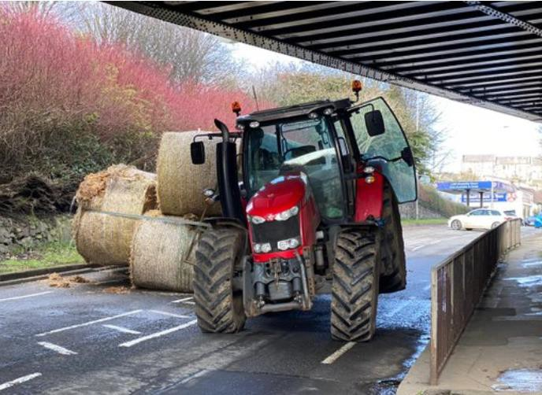

|  |  |  |  |  |  |  |  |
| --- | --- | --- | --- | --- | --- | --- | --- |
| TRUST 817374 XQLI | | | | | | | |
| Cancelled | 19 | Part Cancelled | 11 | Trains Delayed | 71 | Minutes | 856 |

|  |  |  |  |  |  |  |  |
| --- | --- | --- | --- | --- | --- | --- | --- |
| ***Region / Route*** | ***Time*** | ***Location*** | ***Bridge No.*** | ***Dispensation*** | ***NWR*** | ***CCIL*** | ***TRUST*** |
| Western | 1440 | Wickwar Tunnel | 114ch. 46.5  yds | DA | 1517 | 2101867 | 817357 XQDZ = 2 pt cancelled = 38 trains = 355 mins. |

***20 ROAD VEHICLE INCURSIONS (NON-LEVEL CROSSINGS)***

None.

***21 TRACTION FAILURES***

## Eastern (North & East) – CCIL 2101618

At 0626, the driver of 6E97, GB Railfreight, 0128 Bardon Hill – Tinsley, hauled by locomotive 66705, declared the train a failure on the Up Worksop line between Nunnery Main line Junction and Woodburn Junction. Services to and from Gainsborough were suspended and services to Lincoln were terminated/started at Sheffield. GB Railfreight initially advised that the locomotive working 4D66, GB Railfreight, 0552 Goole – Doncaster, would be utilised to assist 6E97 from the front, but then reported at 0752 that the driver of 4D66 did not sign the route required. DB Cargo were requested to assist and reported that locomotive 66090 at Tinsley would be able to assist. The assisting locomotive was attached to the front of the failed train at 0900 and 6E97 was assisted to destination at 0915.

|  |  |  |  |  |  |  |  |
| --- | --- | --- | --- | --- | --- | --- | --- |
| TRUST 816166 MPET | | | | | | | |
| Cancelled | 5 | Part Cancelled | 7 | Trains Delayed | 15 | Minutes | 353 |

## Eastern (East Coast) – CCIL 2101662

At 0736, the driver of 1P05, Govia Thameslink Railway, 0636 Peterborough – London Kings Cross, formed by units 365538 & 365511, reported that the train had come to a stand on the Up Fast line between Potters Bar and Hadley Wood initially with an unsolicited brake application. At 0756 Govia Thameslink Railway advised that the driver had activated the emergency bypass switch and the service would proceed to New Barnet where it was terminated and sent ECS to Hornsey depot, clearing the line at 0813. A following service made an additional stop at New Barnet to collect the passengers.

|  |  |  |  |  |  |  |  |
| --- | --- | --- | --- | --- | --- | --- | --- |
| TRUST 816318 METD | | | | | | | |
| Cancelled | 6 | Part Cancelled | 4 | Trains Delayed | 88 | Minutes | 624 |

## Eastern (Anglia) – CCIL 2102984

At 1925 the driver of 4S88, Freightliner, 1433 Felixstowe – Coatbridge, formed by 25 vehicles = 796 tonnes, hauled by locomotives 86612 & 86607, reported that the train had stopped out of course on the Up Main line approaching Shenfield with loss of power due to loss of communication between the two locomotives. The driver was able to overcome the fault and 4S88 went forward at 1940. Significant reactionary delays were incurred due to congestion.

|  |  |  |  |  |  |  |  |
| --- | --- | --- | --- | --- | --- | --- | --- |
| TRUST 817973 MDBF | | | | | | | |
| Cancelled | 0 | Part Cancelled | 2 | Trains Delayed | 61 | Minutes | 665 |

## Eastern (North & East) – CCIL 2101874 / Fault No. 789395

At 1420 a landslip was reported five metres from the running line at Golcar Viaduct, between Slaithwaite and Huddersfield. P’Way staff were sent to site to investigate and advised at 1621 that the landslip was worsening and that it would eventually affect the running line. An Earthworks engineer was sent to site and at 1653 a Track Section Manager who was present, advised a 20 mph ESR needed to be imposed on both the Up and Down Huddersfield lines. Services were cautioned past two signals in each direction. The ESR boards were in place at 2200 on the Down Huddersfield line and on the Up Huddersfield line by 2352. Further examination of the site was scheduled during daylight hours.

|  |  |  |  |  |  |  |  |
| --- | --- | --- | --- | --- | --- | --- | --- |
| TRUST 817588 IQGG | | | | | | | |
| Cancelled | 7 | Part Cancelled | 5 | Trains Delayed | 116 | Minutes | 987 |

## Eastern (North & East) – CCIL 2101267 / Fault No. 814166

At 1753 (Wed) the Senior Asset Engineer reported that due to the flooding from the River Aire (see below) they had deemed the Down Drax line unfit for traffic between Drax Junction and Drax Power station. A block to freight services towards Drax Power station was then imposed. Divers were sent to site to ascertain the severity of the floodwater. Following a 1400 route conference, Single Line Working was introduced at 1630 over the Up Goole/Up Drax Branch between Sudforth Lane East Junction to the Drax boundary with a 5 mph ESR imposed through the West Bank Level Crossing (AHBC) area. Following the passage of a route proving train, 6Z61, Freightliner Cargo, 1530 Milford WS – Drax, which arrived at Drax at 1728, the line was reopened with the 5 mph ESR in place. The restriction will remain in place pending further daylight inspection tomorrow.

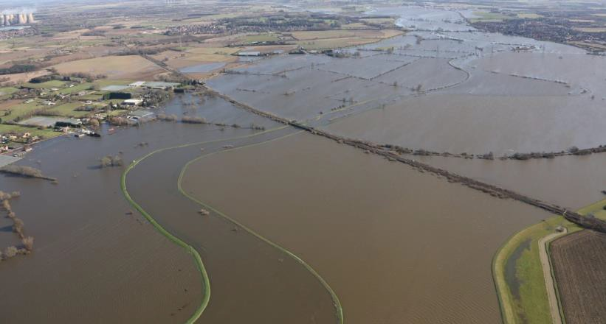

|  |  |  |  |  |  |  |  |
| --- | --- | --- | --- | --- | --- | --- | --- |
| TRUST 814166 IQIE | | | | | | | |
| Cancelled | 13 | Part Cancelled | 5 | Trains Delayed | 4 | Minutes | 98 |

***23 FIRES***

None.

***24 WILD REPORTS & HABD ACTIVATIONS***

## Wales and Western (Western) – CCIL 2101570

At 0425, 6A25, Freightliner 0251 Tytherington - Appleford, activated Alderton line Wheel Chex system with axle 14 RHS wheel flat, 474kN, level 3 alarm and axle 17 RHS wheel flat, 465kN, level 3 alarm. The train was stopped, and the driver advised to proceed at 20 mph to Swindon for RST examination of vehicles VTG 3202 and VTG 3206, as per consist.

|  |  |  |  |  |  |  |  |
| --- | --- | --- | --- | --- | --- | --- | --- |
| TRUST 816083 MDBH | | | | | | | |
| Cancelled | 0 | Part Cancelled | 0 | Trains Delayed | 1 | Minutes | 27 |

## Wales and Western (Wales) – CCIL 2101589

At 0456 6M76, DB Cargo, 2356 (Wed) 2356 Margam – Dee Marsh, activated Tram Inn Up Main line Wheel Chex system with axle 65 RHS wheel flat, 478kN, level 3 alarm and axle 66 RHS wheel flat, 448kN, level 3 alarm. The train was stopped, and the driver advised to proceed at 20 mph to Hereford for RST examination of the vehicle, 8747670267, as per consist.

|  |  |  |  |  |  |  |  |
| --- | --- | --- | --- | --- | --- | --- | --- |
| TRUST 815993 MWAM | | | | | | | |
| Cancelled | 1 | Part Cancelled | 1 | Trains Delayed | 0 | Minutes | 0 |

## Disconnected Hot Axle Box Detectors:

|  |  |  |  |  |  |  |  |  |  |
| --- | --- | --- | --- | --- | --- | --- | --- | --- | --- |
| *Region / Route* | *Location* | *Line* | *Date Disconnected* | *Reason* | *TOC’s/ FOC’s*  *advised* | *Planned Restoration Date* | *Date Restored* | *Function* | *Fault Number* |
| Eastern (Anglia) | Brentwood | Down Electric | 10/03/16 | Offline | Y | Awaiting update |  | IM | 234632 |
| Eastern (Anglia) | Brentwood | Down Main | 10/03/16 | Offline | Y | Awaiting update |  | IM | 234632 |
| Eastern (Anglia) | Margaretting | Up Main | 19/09/19 |  | Y | Awaiting update |  | IM | 298498 |
| Eastern (EM) | Branston | Up Tamworth | 18/02/20 | Defective | Y | Awaiting update |  | IM | 154332 |
| Eastern (EM) | Chiltern Green | Down Slow | 11/07/19 | Defective | Y | Awaiting update |  |  | 148559 |
| Eastern (EM) | Napsbury | Up Fast | 11/07/19 | Defective | Y | Awaiting update |  |  | 148559 |
| Eastern (EM) | Langley Mill | Up & Down Erewash Slow | 13/02/20 | SK4 fault | Y | Awaiting update | 18/02/20 | IM | 1564199 |
| Eastern (LNE) | Barkston | Up Main | 01/04/19 | Removed for P’Way work | Y | Awaiting update |  |  |  |
| NW & Central (NW) | Bolton-le- Sands | Up Main | 25/08/19 | Integrity Fault | Y | Awaiting update |  |  | 863361 |
| NW & Central (NW) | Hest Bank | Up Main | 25/08/19 | Integrity Fault | Y | Awaiting update |  |  | 863360 |
| NW & Central (NW) | Low Mill | Down Main | 26/11/14 | Awaiting replacement | Y | Awaiting update |  | IP | 671852 |
| NW & Central (NW) | Sutton Weaver | Down Main |  |  | Y | Awaiting update |  |  |  |
| NW & Central (WCMLS) | Bradnocks Marsh (Coventry) | Up Main | 29/12/19 | Integrity | Y | Awaiting Update |  |  | 872142 |
| NW & Central (WCMLS) | Castlethorpe | Up Fast | 27/11/18 | Error code 6.0 | Y | Awaiting Update |  | IM | 832410 |
| NW & Central (WCMLS) | Harecastle | Up Main | 01/04/19 | Rail incorrectly drilled | Y | Awaiting Update |  |  |  |
| NW & Central (WCMLS) | Penkridge | Up Penkridge | 04/11/19 | Integrity | Y | Awaiting Update |  |  | 870982 |
| Wales & Western (Wales) | Dainton | Down Main | 17/11/19 | Defective PC | Y | Awaiting Update |  | IM | 453850 |
| Wales & Western (Wales) | Pembrey | Up | 17/02/20 | Constantly alarming | Y | Awaiting Update |  | IM | 460854 |
| Wales & Western (Western) | Cogload | Down Main | 25/01/20 |  | Y |  |  |  | 458740 |
| Wales & Western (Western) | Treverrin | Down Main | 01/07/19 |  | Y | Awaiting Update |  |  | 443474 |
| Wales & Western (Western) | Twerton | Down Main | 19/11/19 |  | Y | Awaiting Update |  |  | 454030 |
| Wales & Western (Western) | Warminster | Up Salisbury | 22/01/20 | Defective | Y | Awaiting Update |  |  | 458111 |

**Disconnected Wheel Impact Load Detectors:**

|  |  |  |  |  |  |  |  |  |  |
| --- | --- | --- | --- | --- | --- | --- | --- | --- | --- |
| *Region / Route* | *Location* | *Line* | *Date Disconnecte d* | *Reason* | *TOC’s/ FOC’s*  *advised* | *Planned Restorat ion Date* | *Date Restore d* | *Function* | *Fault Number* |
| Eastern (EC) | Sessay | Up Slow | 18/06/2019 | Calibration |  |  |  | IM |  |
| North West & Central (NW) | Heaton Chapel | Up Slow | 30/07/2019 | Calibration |  |  |  | IM |  |
| Southern (Kent) | Sevington | Down Main | 25/04/2018 | PC Failure |  |  |  | IM |  |
| Southern (Kent) | Sevington | Up Main | 09/08/2018 | PC Failure |  |  |  | IM |  |
| Southern (Kent) | Swanley | Up Slow | 02/04/2019 | Calibration |  |  |  | IM |  |
| Scotland | Howwood | Up | 20/01/2019 | HOBC |  |  |  | IM |  |
| Wales & Western (Western) | Urchfont | Up | 11/04/2019 | PC Failure |  |  |  | IM |  |
| Wales & Western (Western) | Urchfont | Down | 11/04/2019 | PC Failure |  |  |  | IM |  |

***25 GROUP STANDARDS GE/RT8250 & GO/RT3350***

None.

***26 TPWS***

|  |  |  |  |  |  |  |  |  |
| --- | --- | --- | --- | --- | --- | --- | --- | --- |
| ***Region*** | ***Route*** | ***Train*** | ***Signal/PSR/ Buffer Stop*** | ***Line/Platform*** | ***Location*** | ***Speed (reported)*** | ***Speed (set)*** | ***CCIL*** |
| Southern | Kent | 9K15, Govia Thameslink Railway, 0802 Luton – Orpington | VS203 | Down Chatham Fast | Bickley Jn | 28 | 34.5 | 2101717 |
| Eastern | Anglia | 4M81, Freightliner, 0801 Felixstowe – Basford Hall | 30 PSR | Up Bury Line | Bury St Edmunds | 45 | N/A | 2101722 |
| Southern | Wessex | 1L38, South Western Railway, 1147 Salisbury  - Waterloo | PSR | Up Main Fast | Clapham Jn | 50-65 | 47 | 2101827 |
| North West and Central | NW | 1F37, West Midlands Trains, 0918 Birmingham International – Liverpool Lime Street | CE107 | Down fast line | Crewe South Junction | 55 | 50.5 | 2101744 |
| Southern | Kent | 2F59. Southeastern, 1740 Orpington – Cannon Street | 20 PSR | Platform 3 | London Bridge | 40 | 37 | 2101958 |
| Southern | Sussex | 9R63, Govia Thameslink Railway, 2135 Bedford – Three Bridges | T257 | Down Slow | Gatwick Airport | 35 | 34.5 | 2102079 |

***27 MISCELLANEOUS***

None.

|  |  |  |
| --- | --- | --- |
| ***INCIDENT*** | ***TODAY’S TOTAL*** | ***DAYS SINCE LAST INCIDENT*** |
| **PASSENGER ACCIDENTAL FATALITIES** | **0** | **449** |
| **RAILWAY WORKFORCE FATALITIES** | **0** | **75** |
| **SIGNALS PASSED AT RED (CATEGORY ‘A’)** | **6** | **3** |
| **SIGNALS PASSED AT DANGER (ERROR/TECHNICAL SIGNAL REVERSION)** | **3** | **0** |
| **DERAILMENTS** | **0** | **1** |
| **TRAIN COLLISIONS** | **0** | **14** |
| **TRAINS STRIKING ROAD VEHICLES** | **0** | **30** |
| **ENVIRONMENTAL INCIDENTS** | **0** | **16** |

